**EXPERIMENT # 11**

**Design of half wave rectifier on PSpice Schematics**

**Objectives:**

How to design half wave rectifier on PSpice schematics.

**Apparatus:**

1. PSpice Schematics
2. PSpice library

**Theory:**

A rectifier is an electronic device that converts AC voltage into DC voltage. In other words, it converts alternating current to direct current. A rectifier is used in almost all the electronic devices. Mostly it is used to convert the main voltage into DC voltage in the power supply section. During the positive half cycle the diode is under forward bias condition and it conducts current to RL (Load resistance). A voltage is developed across the load, which is same as the input AC signal of the positive half cycle.

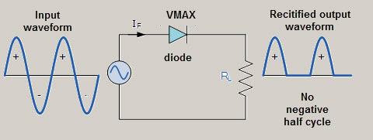

Fig 11.1 Half wave rectifier

Alternatively, during the negative half cycle the diode is under reverse bias condition and there is no current flow through the diode. Only the AC input voltage appears across the load and it is the net result which is possible during the positive half cycle. The output voltage pulsates the DC voltage.

**Procedure**

1.choose resistor, sin wave, diode and ground from PSpice.

2. Connect them according to 11.1.

3. Click on setup analysis and click on transient.

4. Then click on plot and select I[R], that will show output.

**Schematic circuit.**

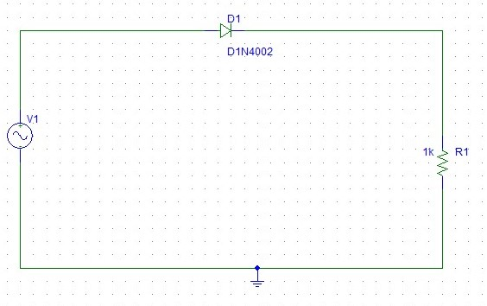

**Output Result.**

